# BRCT Motorway Roading information Setup.

As advised we will not implement the system but pass it over to the person in charge of BRCT information technology with instructions on how to configure.

If they would like help or have trouble setting up the system we are happy to be contacted and help out.

## Setup

### Requirements:

* Webserver running php 5.5 and Maria DB or mysql
* Google Developer account

### Website files required in root of website folder:

* Index.html
* Images/
  + background_viewsource.png
  + brct_bg.jpg
  + cow_small.png
  + crash_small.png
  + go_small.png
  + logo.png
  + snow_small.png
  + stop_small.png
  + viewsourcelogo.png
  + works_small.png
  + yo_small.png
* locations.php
* script.js
* styles5.css

### Connection folder in root of server:

/connection/connect.inc.php

-set 700 permissions recursively on the /connection folder

-set the owner /connection recursively to www-data, remove the group permission.

### Setting up Database

The /connection/connect.inc.php file stores the credentials that php uses to connect to the database. This file will need to be updated with the correct credentials of the database and account that you decide to use with your implementation.

Create a database called ‘Mototway_DB’, create an account that can update and insert into tables in the Motorway_DB database. Add the username and password of this newly created account to the connect.inc.php file in the appropriate fields.

To create the correct tables for the database run the DDL script Motorway_DB_appV2.sql with an account that has the rights to create tables.

### Google Maps API key

You will need to create a google developer account and generate a browser api key from the Google developer console, when creating this key you need to enter the domain or ip address of where the site will be hosted see example in screen shot. 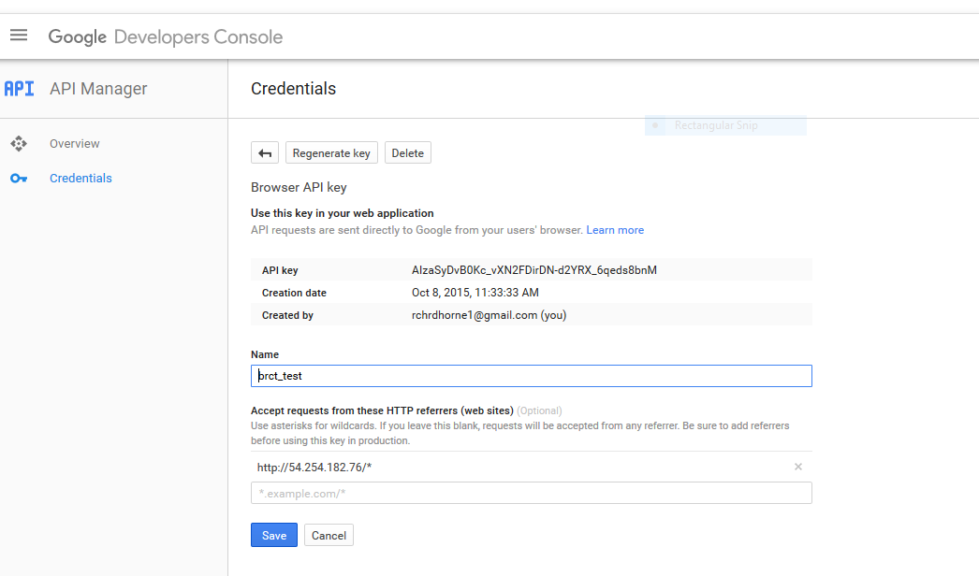Once you have generate this key you will need to add it to the script tags that have the google maps api address, in the file index.html. See screen shot below.

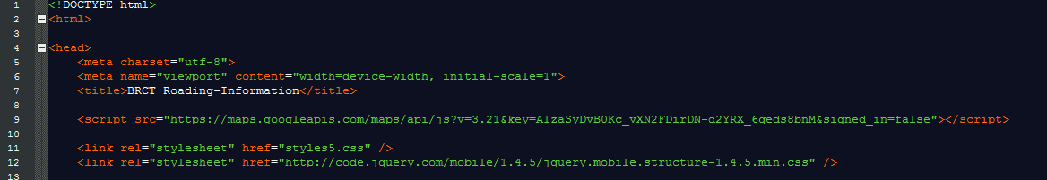

### Set URL to locations.php in ajax calls.

You will need to update the url that ajax uses to send post and get request to locations.php.

This url is set in script.js on the variable 'ajaxurl' this will need to be update to the location of where the locations.php is now hosted.



This should be all that is required, for any issues getting set up please feel free to contact one of the JAR Technical team.